Blubs Survival

Story

The main story of the game is the main player finds out the princess that he wanted to save. Has been kidnapped by the evil viallian this is going to lead the main player though different levels. As the main character goes thourgh the different levels he will survive different traps and enermies that want to kill him.

Once he has survived the different traps and enimes that lay await he is going to be able to face the final boss. Using lots of courage and all his might he is going to be able to take down the final boss thus allowing him to defeat the evil villain and save the day. Thus allowing the main player to be able to save the proncess and marry her.

Level structure

Scripts

When looking at the different scripts that had been created, I have moved all these into different folders, I made a folder for the main character blub and then folders for each of the levels to allow me to separate the scripts easily so I don’t keep getting the scripts mixed up. Then lastly a UI folder to allow me to have scripts to help with the creation of my UI.

Blub Scripts

The first script that I used for my character is a script called Blub, this script is empty the main purpose for this script is mainly for level 2 and the boss battle. As the different enemies are there such as the skeleton and the final boss as they shoot projectiles at blub. As in their script which I will go into detail in the level 2 part of the documentation as they need to target blub in their script, so I needed to make an empty script named blub which is applied to my main character.

Then I made blub to be able to have a level respawn this is done by the player pressing the Q key how this works is by linking two scripts together. The first script of the two is Blubs Position this is linked to the blub character the main purpose of this is the Q key, and to reload the scene so the respawn key can work.

Then the second script linked to this I created a new game object called StoreBlubsLastPos then I link the script which has the same name, in the script it checks blubs position via the X and Y axis, then doesn’t destroy on load if this is null if it isn’t then it destroys the game object. Once this is added to StoreBlubsLastPos you can input the X and Y axis which I set as the beginning of the level to create a level respawn.

Then In the last script which is player movement this is the biggest script for blub as this controls all the major inputs for blub. In the player movement script, it allows me to set the speed of blub, how high I want blub to be able to jump to be able to cross platforms. Then I was able to add an audio source for the jump this is so when I press the space key to allow me to jump a sound will play so the player can be acknowledged that the input is working.

Then I was able to set what is ground this is to add a layer which is used for when making my character to jump what I did on all the platforms I wanted blub to be able to jump I set the layer to ground so the script is able to read what is ground and to know that blub is able to jump of that layer.

Then I needed to set a game object to be a child of blub this was called blub feet pos as I use it to check the floor radius so blub knows how far the floor is beneath again, so he knows that he is on the right position of the ground to jump off. Then lastly there is the void for the letter collected this is so when blub collects the love letter the Ui is going to update with the letter being collected and the sound of wedding bells is going to play to remind blub of his quest.

Down in the appendices you can see snippets of the scripts with comments to be able to understand more about what each void does.

Level one Scripts

Then looking in the level one folder the first script that I created was the lava death this was made for when the player falls into the lava and dies how this works is I create two serialize fields which are private transforms, this allows me to be able to set the player and the respawn point. The best thing about this script that I created is how it allowed me to use this simple script but in so many ways in my game.

Using a collider, I get the position for the player which is blub and have it equal the respawn point so when player touches the collider they spawn on the respawn point. Also, I added in a audio source to allow me to be able to add in a death down when the player dies. Spike death the next script is the same as lava death I gave them different names so people wouldn’t be confused.

Then moving onto the missile death script this script covers the colliding like the spike death script but also goes over the patrol, I use patrol as a way of moving my object around to be able to create a patten which is used to catch the player of guard. I set the Ignite missile time this allows me to be able to set a time for the missile to wait to allow the player a chance to doge the oncoming object. I class the missile stopping as stalling as its something every machine can do.

I then set up an arreay this is where the missile is going to attack randomly as I find things attacking randomly far challaning to overcome rather then something having a set pattern. Looking at the Saw death this has the same information as the missile death and the spike deatht he main difference is the missile rotates instead of stalls, I made the names make sense for the different objects. For example, you wouldn’t have a saw stall.

Then the next script which is used is the load letter script this script is used to bring up the letter at the end of the level to tell the player where they are going. The first part of the script works like spike death I define the blub for the collider and this time make what he is going to collide into the final flag as this marks the end the level, thus this takes the player to the letter left by the princess. The second part of the script uses a screen manger for a trigger void to load the letter scene.

Then the last script is for the letter this uses a button I use the get component methord for a button and apply a void called enter second level once this button is pressed the void loads the scene, allowing the player to be able to enter the second level.

Level 2 Scripts

Boss Fight Scripts

Ui Scripts

Looking at the UI scripts that were created to help me with the creation of the UI the first scropt that I created for the UI was for the menu this script allowd me to add the buttons to the gsme which allowed me to have a play button which is used to start the game. An objective button which allowed me to take me to the objectives screen to show the player how the game is platyed.

The next button that was in the script is the controls button this allowed me to have the player to be taken to a screen which allowed them to see the controls of the game and how to play. Then the last button for the menu screen that the script let you used was the exit button screen thid butto is there as a way to quit the game.

The next script being the countdown script the script uses the canvas UI as a way to show the player how much time they have left to complete the level. If the timer runs out then the player automatcly loses the game. it works by overidding the the canvas text to display the time once the time runs out it switdhes the screen to the game over UI which uses the game over script. So looking at the Game over script there are two major choices the player has when he reaches this screen. They are forget her which ends Blubs quest and causes the game to close, or save her which reloads the game and allows the player another shot and trying to save the princess.

Then as spoken about earlier the how to play UI In this section I have created images off the different key presses this is due to I wanted two different ways of being able to explain to the player how to play the game. The first way being an image as some people find reading difficult. Then the second way being writing how to play as some people have better undsatadding when they read something compared to seeing an image.

Then the last script being about the objective mentioned this ive akready covered what the purpose of this menus is however it does have a button which allows the player to be able to be taken back to the menu screen nce they have read the quest bjective

Sprties

Spties have been added to the game the reason why the sprites have been incorporated into the game is due to they are used for every aspect of creating this game. for example I used sprtites to create the terrain and the character. There are some sprites which I created such s the main character and the tarian for the levels. However there are other sprites that I have used of the internet and the main reason I did that was due to im showing how I can program to the best of my ability.

Also adding sprites to the game allows thw player to create and UI for example I could of just had a menu woth some text that said game over but creating sprites allowed me to add images into my menu. Say for example when you receive a game over in the gsme you see that the two weddings rings that were in the you win screen are now shattered into pices. Thus meaning the player will see that he failed his quest to save his love and furfil his dream of getting married.

The next main feature of having sprites is that they allow me to be able to create animations for my characters and the different objects in the game. I will be talking about the animations on the next part of the report.

Animations

Moving onto animations you can see that animations used in a game can make the players and the eremies far better for example I added animation to my player when he jumps his legs go up this makes the player look like he turns into a ball when he jumps into the air. Addign animations like this make the game feel more real for example if you didn’t add any animation to someone walking then the player or the ai just slides against the wall thust making the character look very stale and boring.

The next part of the aniamtions have been created is that they are then saved so if I create an walking animation for my player I can save the animation that I had then just ceated and it allows me to add it onto my Ai. The main benerfit of this being I don’t have to keep remaking walking animations as I will then start to end up with some many different walking animations im going to end up getting confused and apply the wrong animation to ther incorrect character.

Level Scenes

Now that I’ve spoken about how the scripts work I should talk about the levels in the game, the first level is set in a factory where blubs love has just been kidnapped thus blub has to try to survive the different traps in this factory such as spikes and saws, so he can reach the letter that his love had sent him telling him where to go to find her thus leading the character to where he has to go to find his love.

Time limit

A constraint that I added to the game is a timer how this works when the player starts the game they are going to see how much time is left of the level. If the timer reaches zero then the player will be taken to the game over screen. Each level will have different times as I beloive some levels are harder then the others.

Level one

So looking at the first level the main character Blub Has to try and escape the factory at the beginning of the level Blub is going to see that straight away the main villain has set off lava thus meaning, as Blub has to try to jump over the different platforms he will have to try to avoid not falling into the lava. If Blub does unfortunately land in the lava then he is going to die and the death sound is going to play this then has blub start at the beginning of the level. You can see the different traps below in the appendices to give you a look of what the different challenges that blub must face.

Once Blub has survived the platforms he will have to face one more challenge before he can reach the check point, this obstacle is missile with the set task of taking out blub once the player as survived the missile, they will reach a checkpoint. Now when blub dies for example by the lava at this point, he is going to respawn at the checkpoint.

Even though blub has hit a checkpoint the level is not going to get easier as his goal from this point is to pick the letter that has been left by his love to tell him where she has been taking to. He will have to doge multiple saws to be able to jump on the platforms once he manages to doge the different saws and the spikes that lay ready to get him if slips up. He will reach an area where the love letter is once the letter has been collected the wedding bells sound will go off remidning the hero of his quest.

Now blub needs to try and survive the wall jump where there is a saw on its way down that’s there to try and eliminate him, there are holes in the walls where blub can hide from the saws to be able to stay safe from the saws that are coming for him.Once blub has jumped and survived the wall jump he will just have to survive the final path then he will reach the exit. In the final path he will have to doge a saw while completing the platform section making sure the player doesn’t fall in the lava or jump on a spike.Once the player reaches the end flag he will be taken to the letter this tells the player what happened to his love and where he will be going. Once it has been decided you click enter level 2 this Is where the player will hear the graveyard sound to let them know where they are heading.

Level 2

Moving onto level 2 the player is going to be starting in a graveyard this is where the main hero is going to finally meet the minions that work for the main villain. The atmosphere is eaire as the creepy music plays to set the ambience. If the player moves to the left he will see a spookey tree with the first trap the villain has set he will see an evil scythe being controlled by the villlians power if the hero runs into the scythe then he is going to end up being killed.

Then the player is going to have to try to avoid a zombie which is the first minion that is trying to kill the main character they will have to try to jump over the enermy. The zombille will move in the patten moving from the far left of the screen to the far right of the platform. So if the player tries to avoid the zombie by running to the far left if the platform they run the risk of the scythe trap. Then if the player gets to the far right of the platform to avoid the zombie they will have to try to jump on the platform before the zombie kills the player or before the scythe on the right takes out the player.

Once the the player has avoided the zombie and the scythes they will be on three grass platforms here are two birds trying to nock the player off the platform if he does fall he will fall in tar and die. Once the player has avoided the two birds they will be able to reach a platform with a tombstone this tombstone is the checkpoint for the level.

Then the player has two choices two different paths to go the top path will lead him to the door to escape and the second path leads to the letter from his love. Heading down the second path the player will have to do more platforming while avoiding the two birds that again want to try to nock you of the platforms to kill you. Once the player has survived the tow birds they will need to use all there wit to try and get past the skelton guarding the letter this enermey will try to shoot the player if you get hit you will end up being sent back to the checkpoint. However to be kind to the player you only need to get the letter once even if you die.

Now back to the first path now that we have the letter we want to head to the door you will have to doge a bird while platforming, try to get past another skelton then lastly try to out manovour a zombie. Once that has been done you will reach the door with a letter telling to where your love is and the final boss that awaits you.

Boss level

Blub UML Diagram

UI UML Diagram

Level 1 UMl Diagram

Level 2 UMl Diagram

Boss Battle UMl Diagram

Testing

Then moving onto testing my game there are going to be different ways im going to test my game, such as using unit testing dioxygen and github. So I shall be talking in more detail below how testing is being completed for my game.

GitHub

GitHub this is a online software what you do is you create a new respotory which was called the name of my game then you link the project to the resportiry know when I ever add something to a game such as a comment, Github will update.Below in the appendice you can see what the project look likes in GitHub. As you can see in that image you can see all the different parts of my project clicking on each part of the project such as the scene you are going to see each part of the project in more detail.

Next you can see on GitHub you can make comments you create a title for the comment such as added in UI into my game and then I can add in a more deffintion below in the second box to explain the steps that I have so the person reading the comments understand what has changed in the latest push. Push is when you push the code with the lates changes and GitHub updates and shows the diffenrence each time there is a push.

This is then what leads us to the main benerfit of Github you can see all the comments that I have made everytime I have pushed my code, what this means is I can click on one of my old comments and see what my project looks like from the past. This then allows me to be able to download an old version of the code.

An example of where this helps is earlier I accidently deleted a part of my program and It would of took hours to remake that part of the game so I downloaded an old pushed version of my project and I was able to see what I did and remake in my latest project which I then pushed with the updated code.

Below you can see a better example of what comments look like and how you can download old versions of your project.

Dexoygen

What dexoygen is it’s another pice of software except this one is diffenernt compared to Github this sort of program you want to use for when the program is being tested by someone else or marked. As for Dexoygen to work you make comments which will come up on the doxeygen page.

The other benerfit of dexoygen which I find the best is that when you use doxygen is that it lays out all of your classes with diagrams and all the comments this makes it easier when you want to be able to read your code far easier that’s why I said the software allows the user to be able to read though the code with ease.

Also allows the code to be easily marked as the person marking will find it esair to look though the dexoygen version of the code, rather then looking thorgh the visual studio version of the code.

Unit testing

Appendices

Blub Scripts

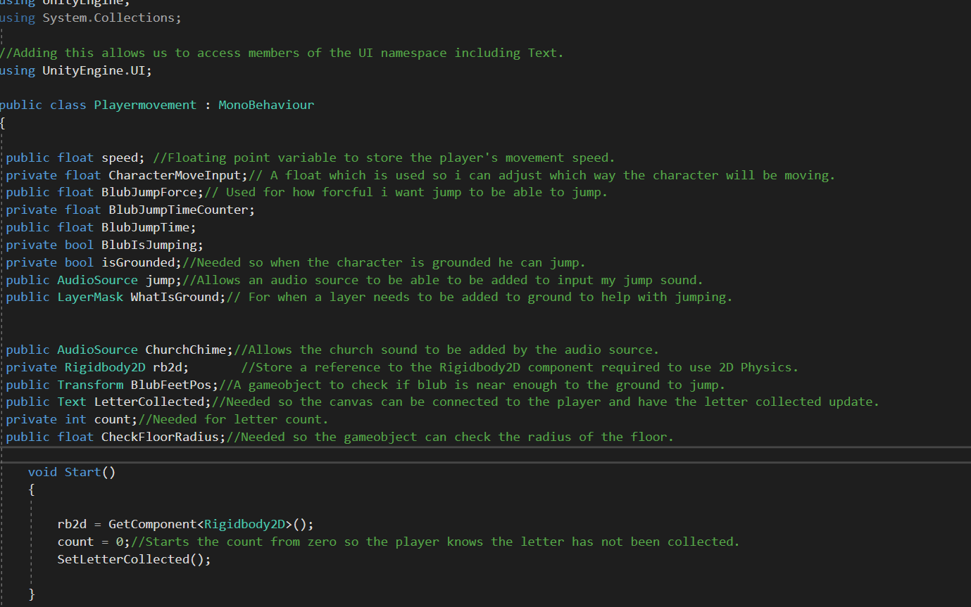

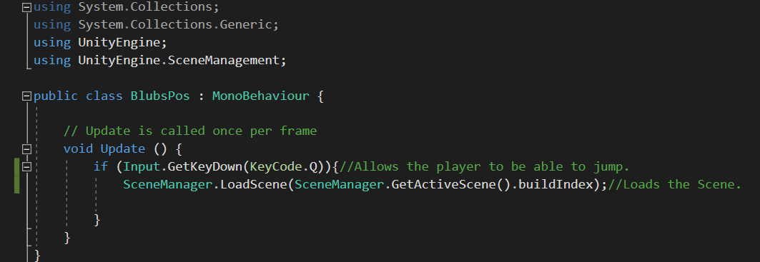

Level one Script

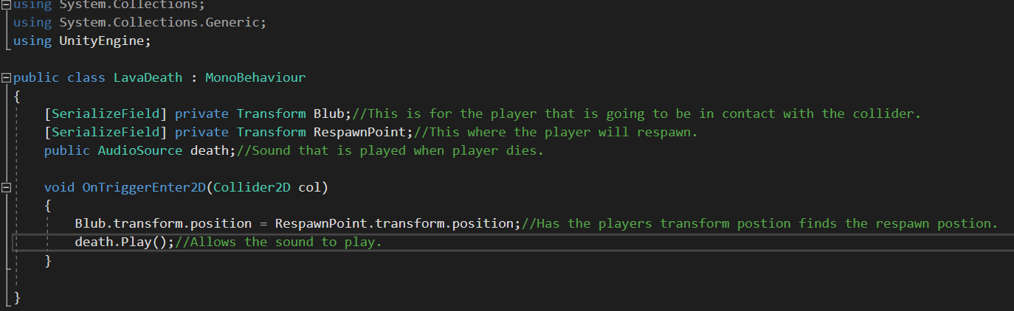

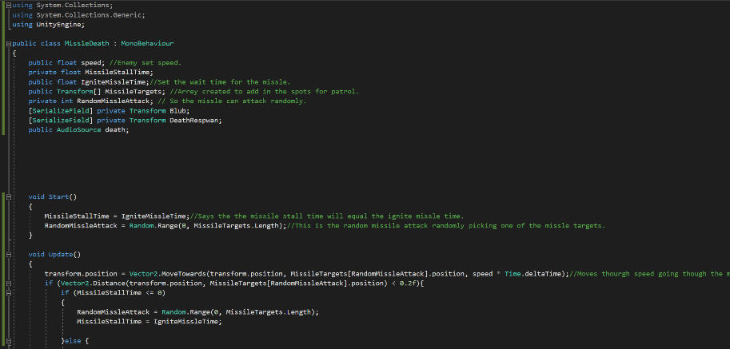

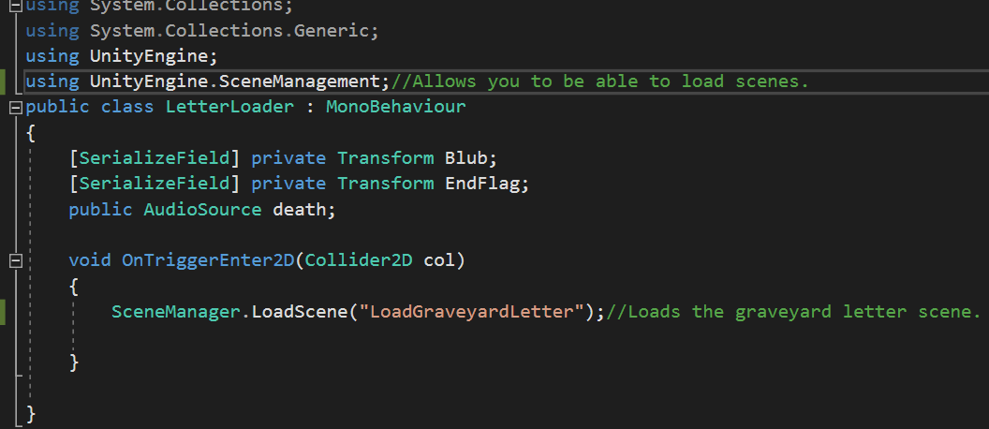

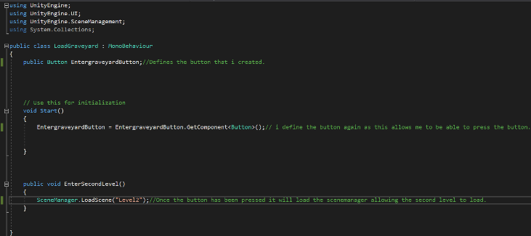

GitHub

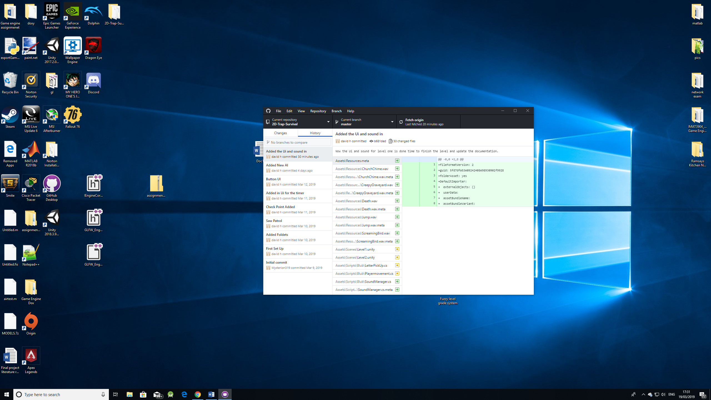

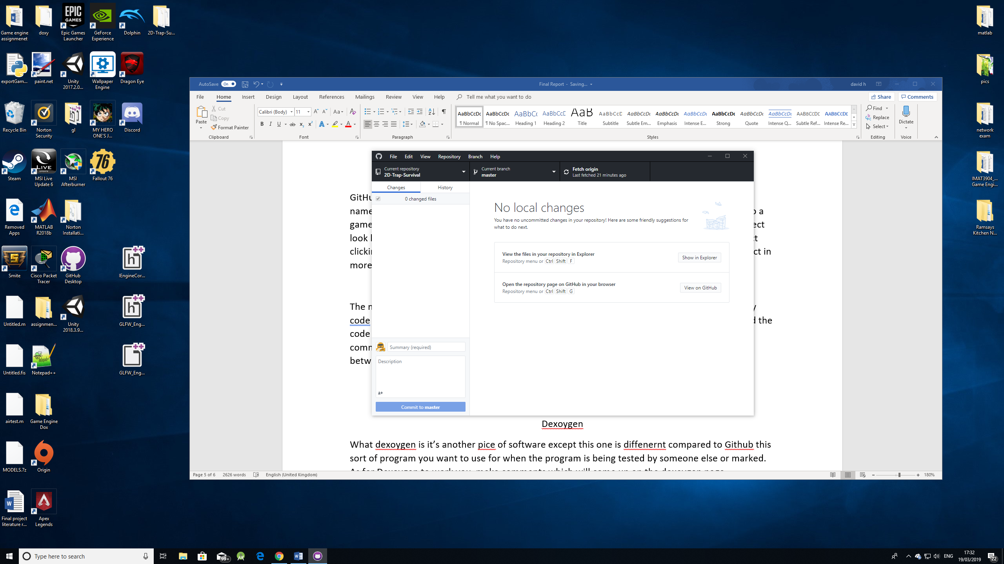

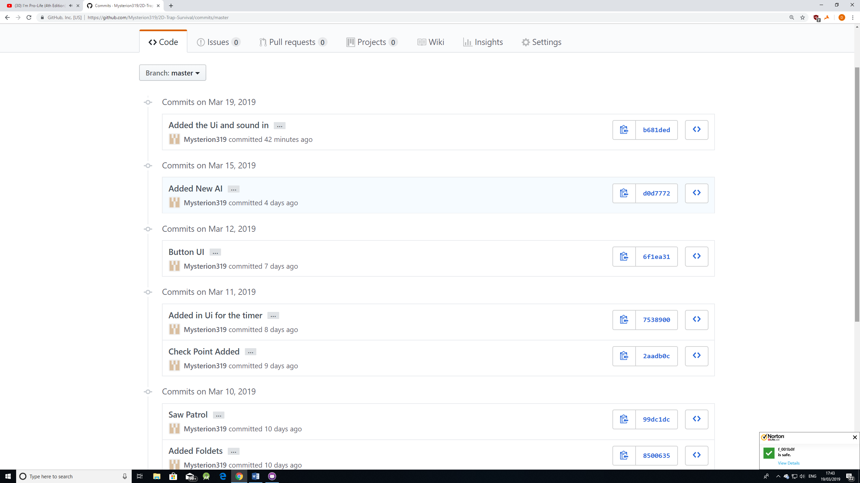

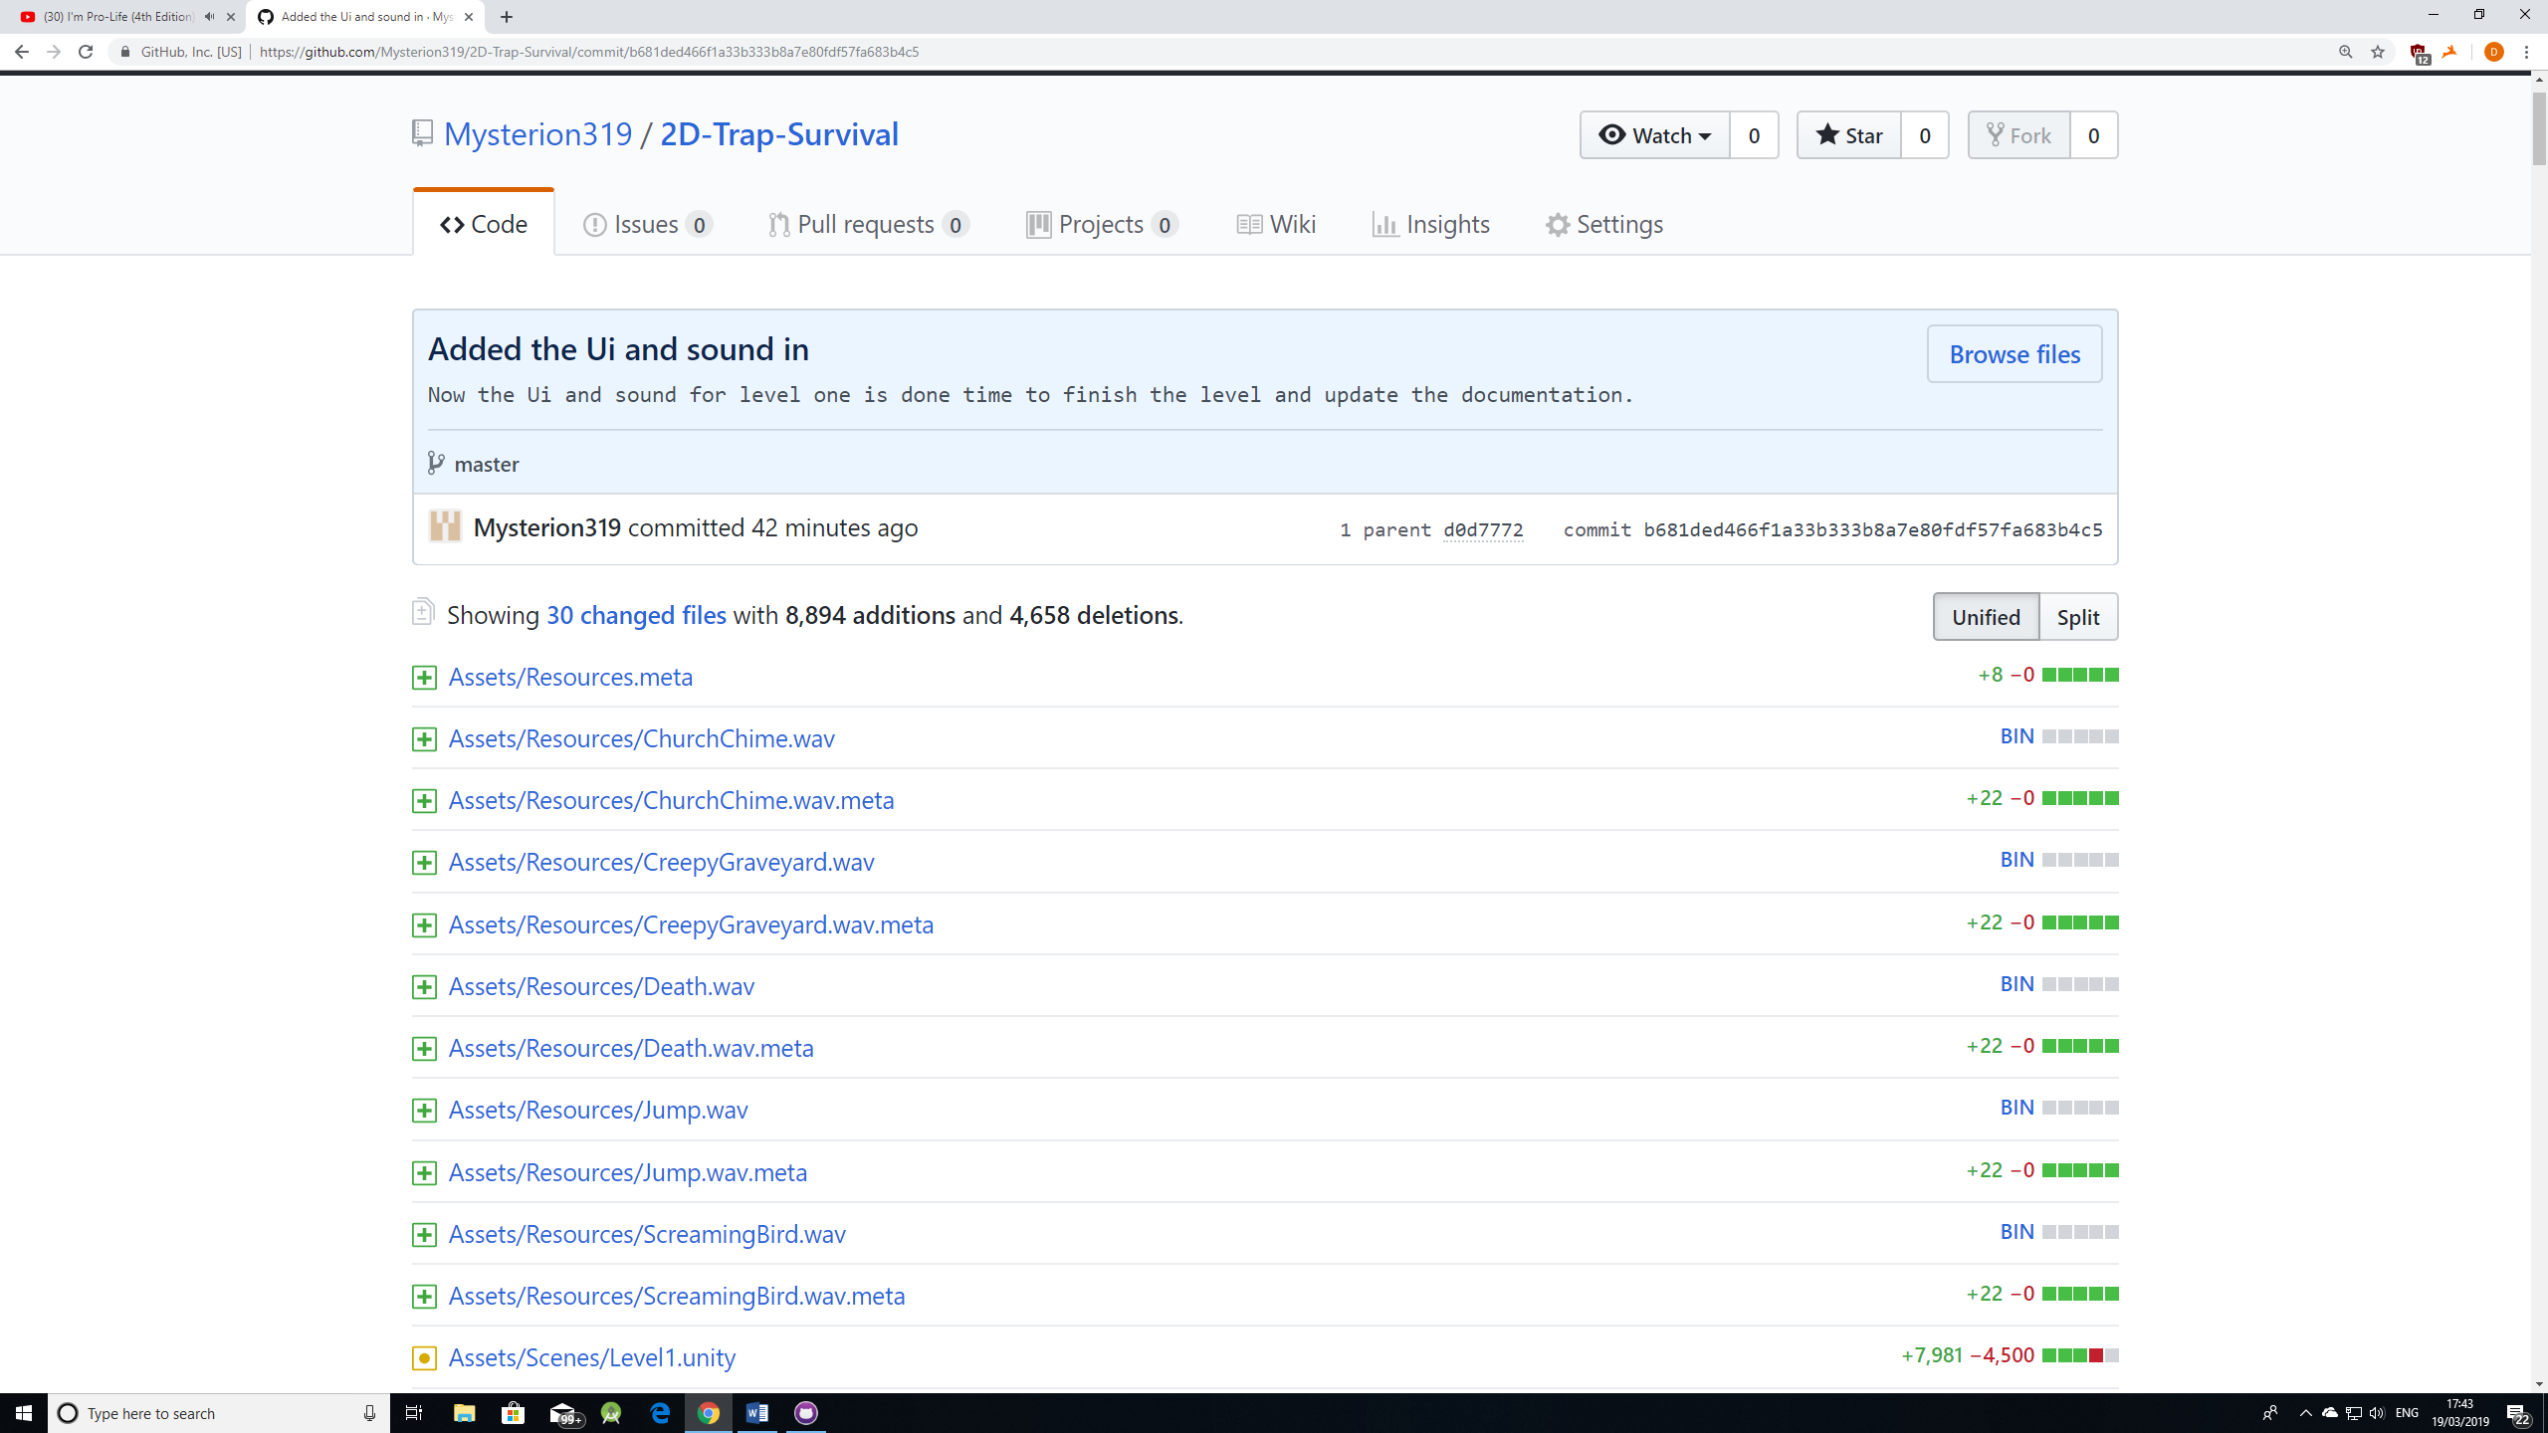

UI scripts

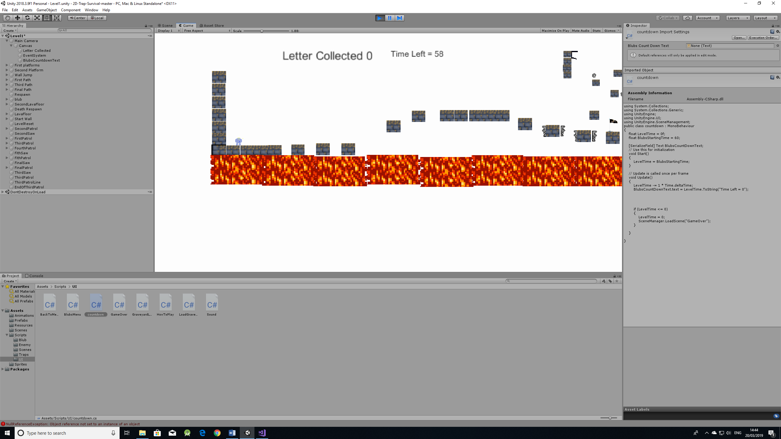

Level one Key

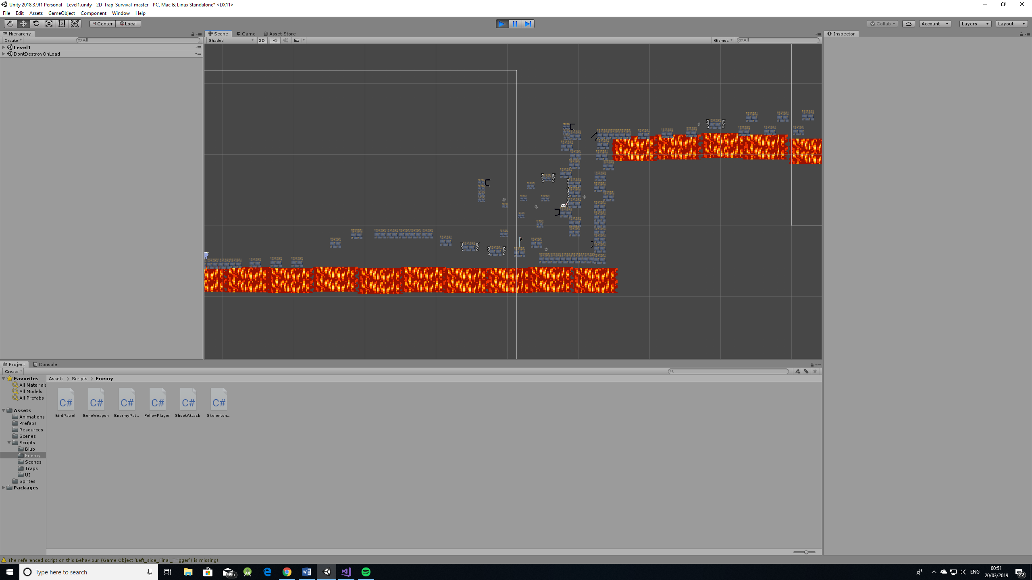

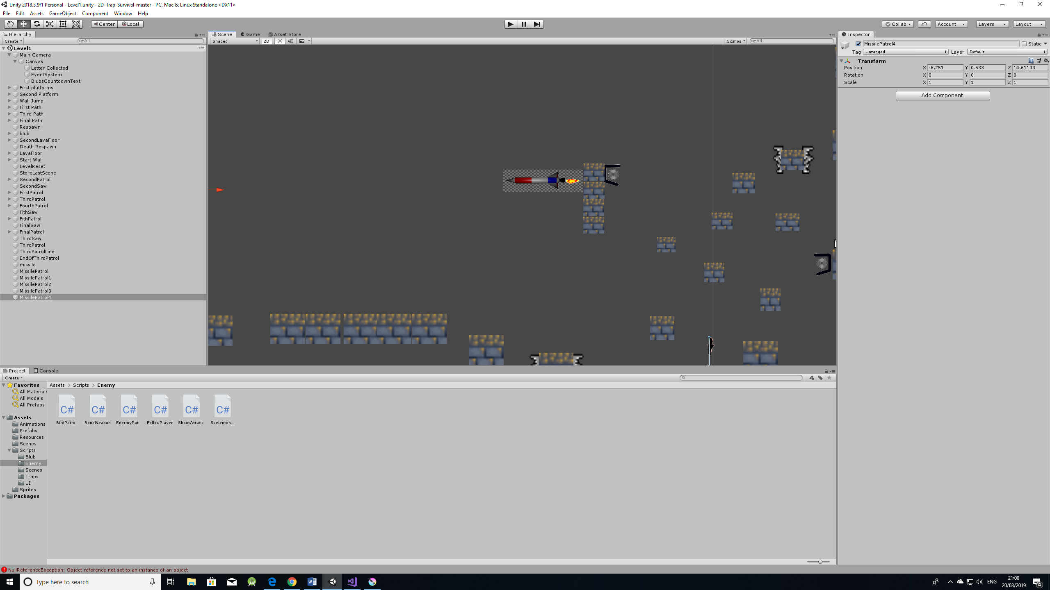

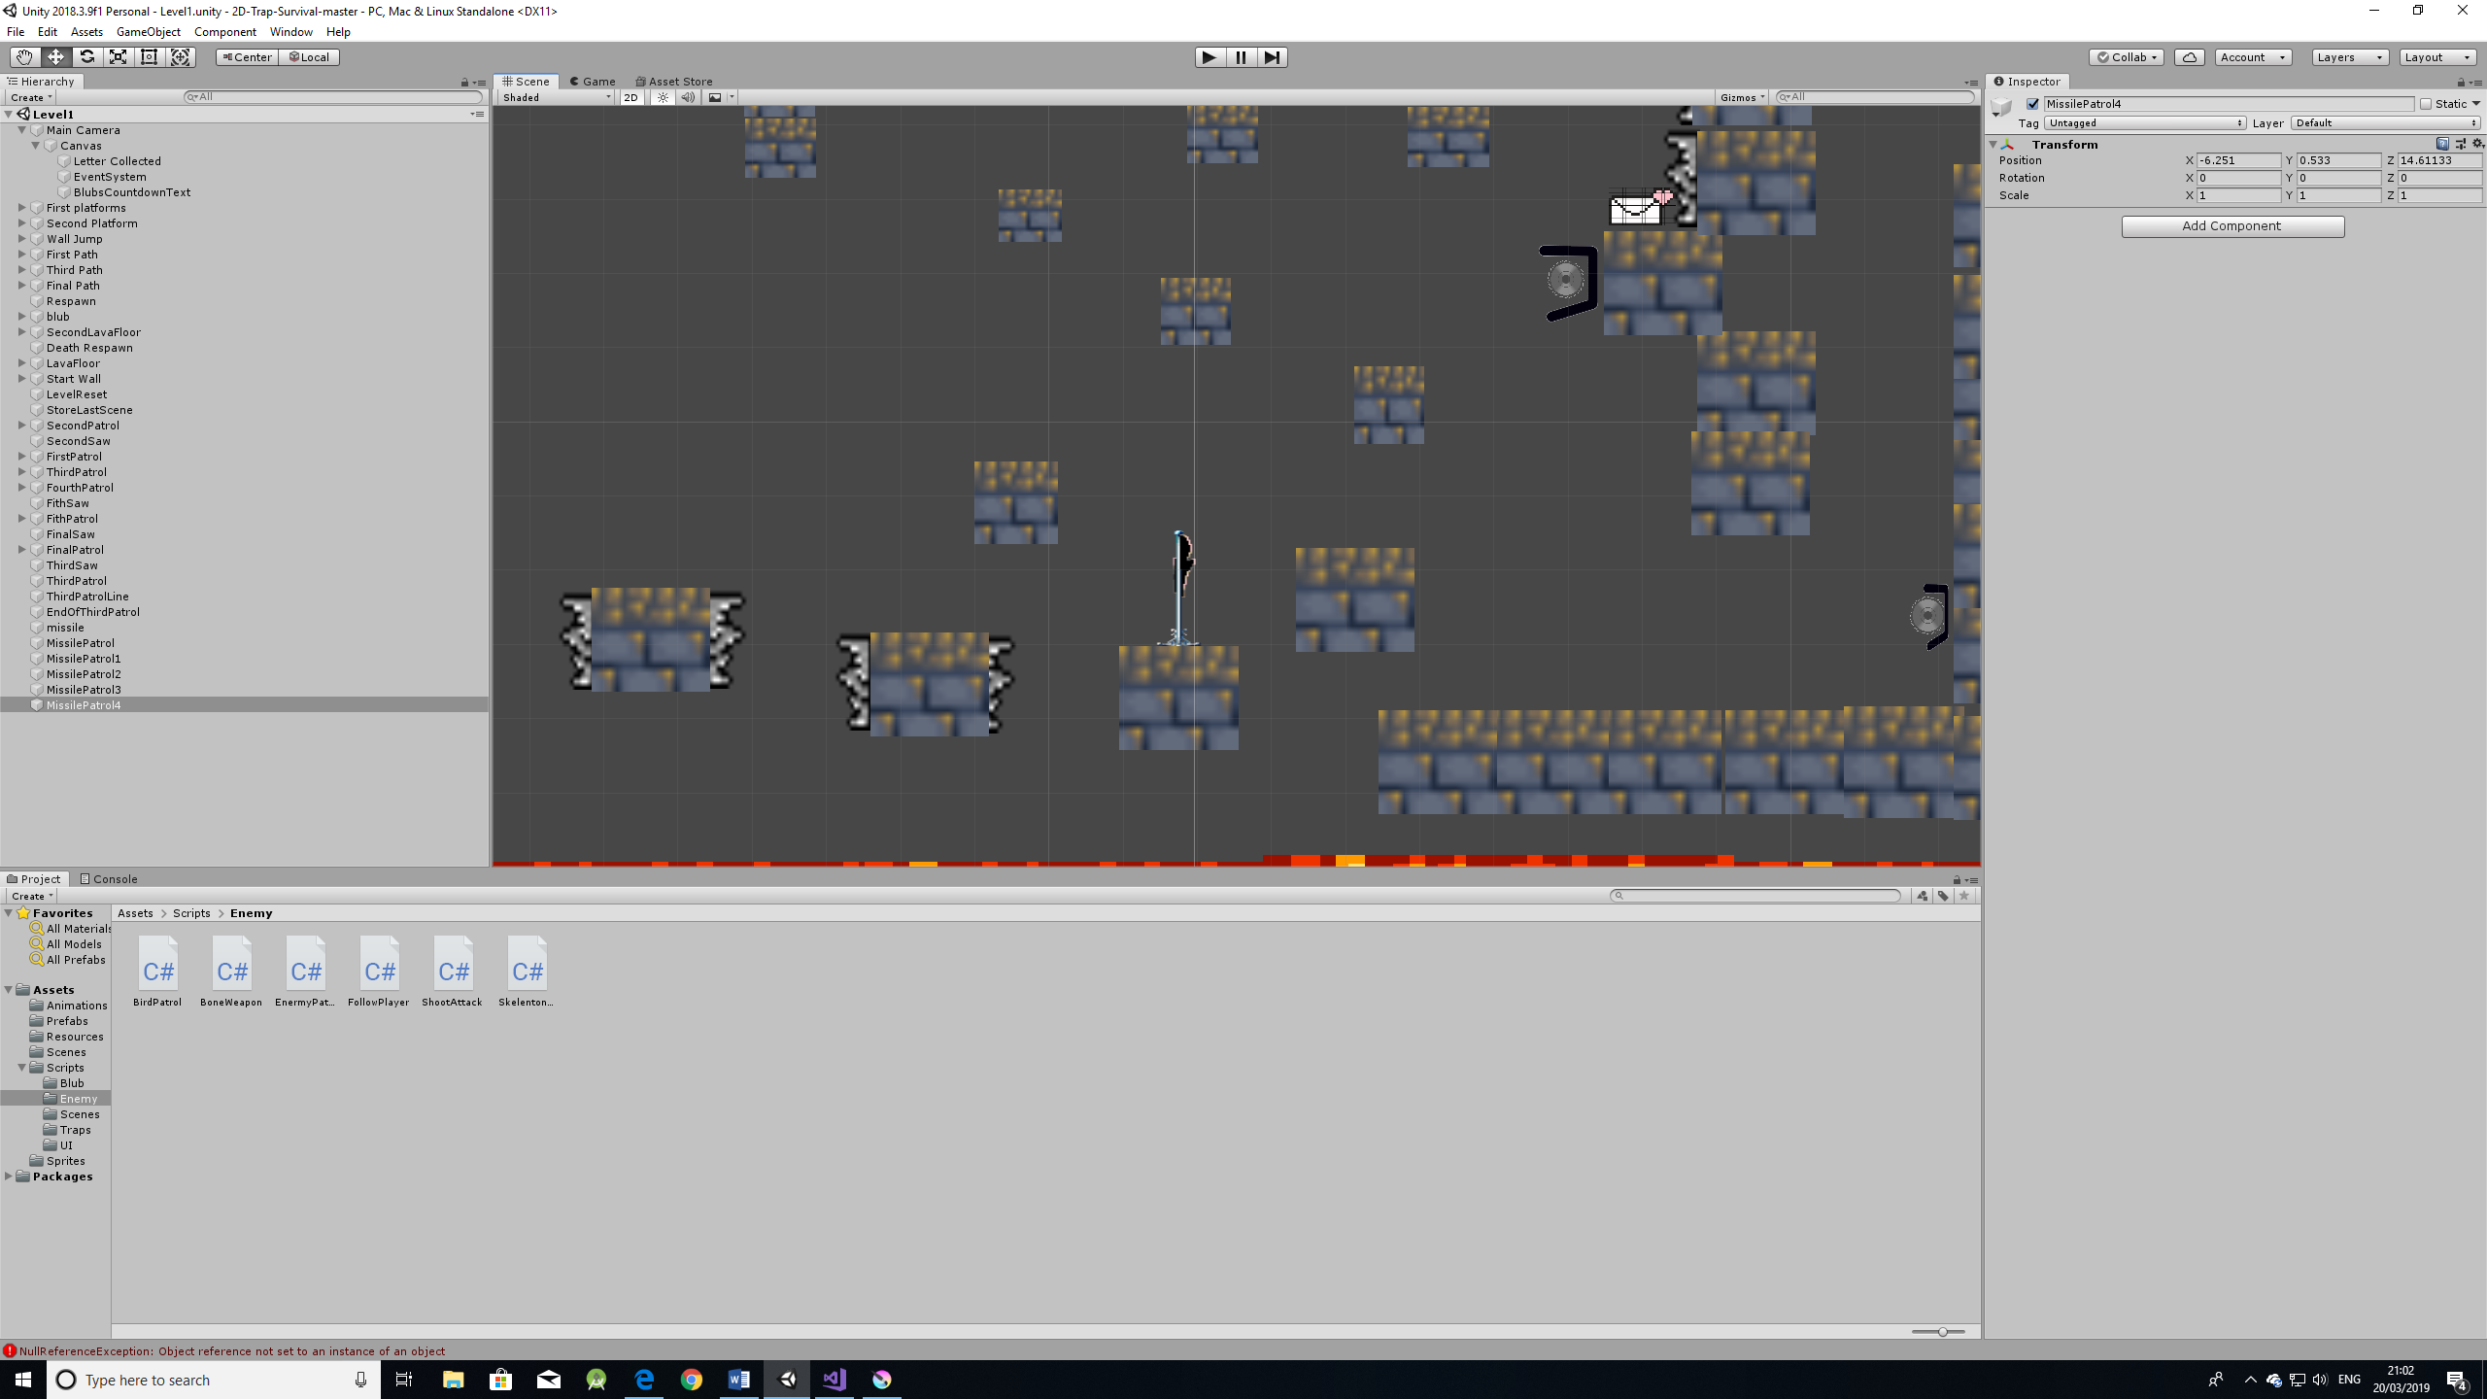

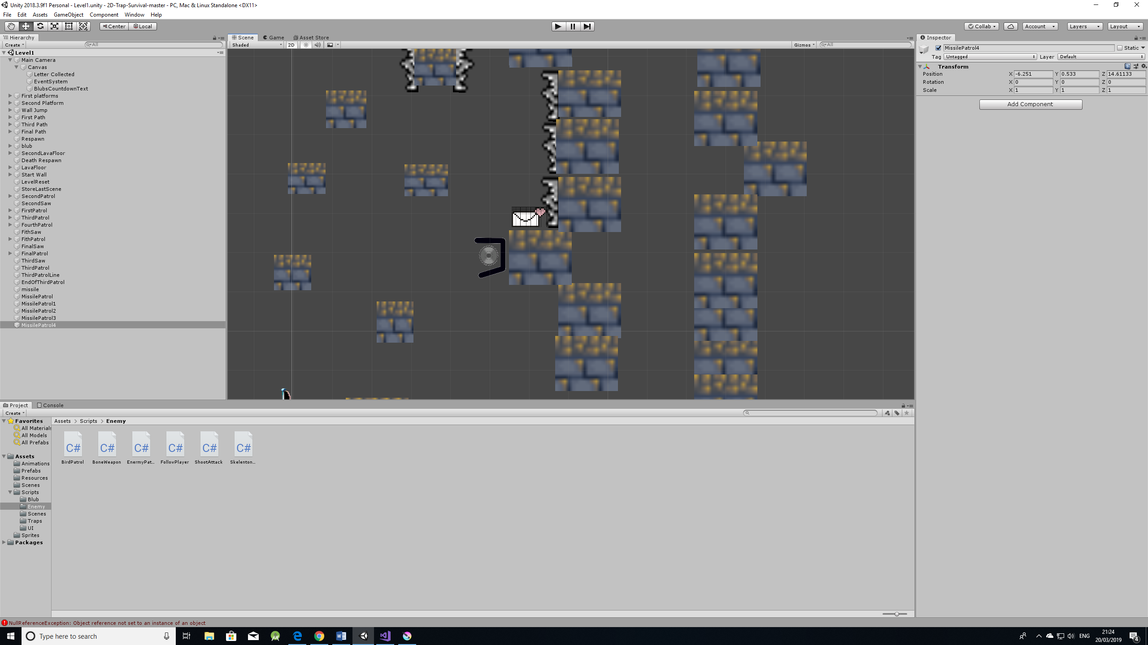



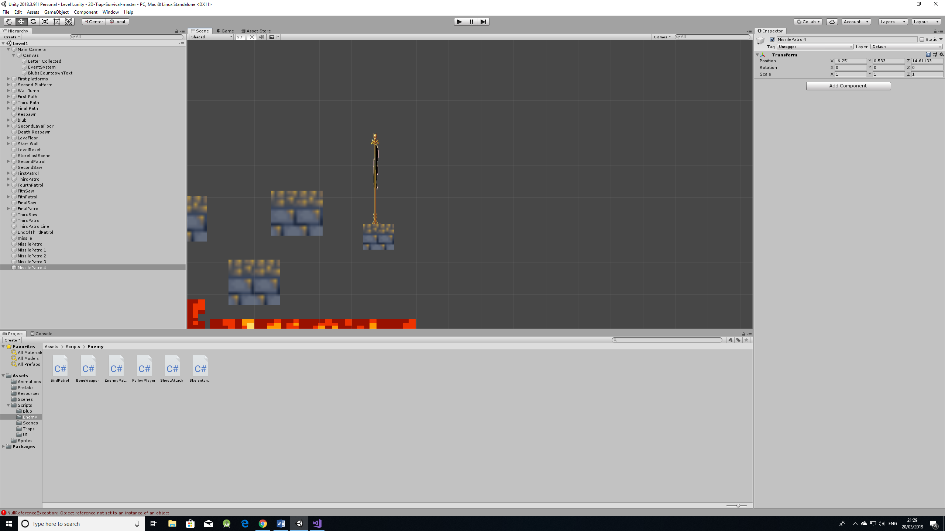

Level 2 key

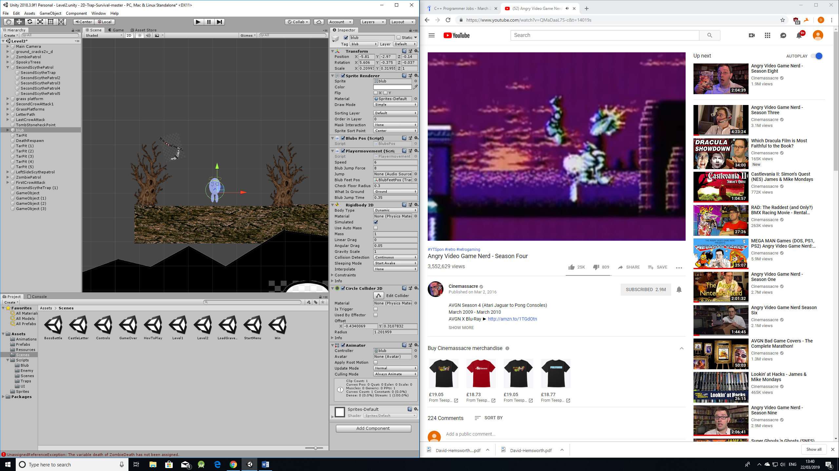

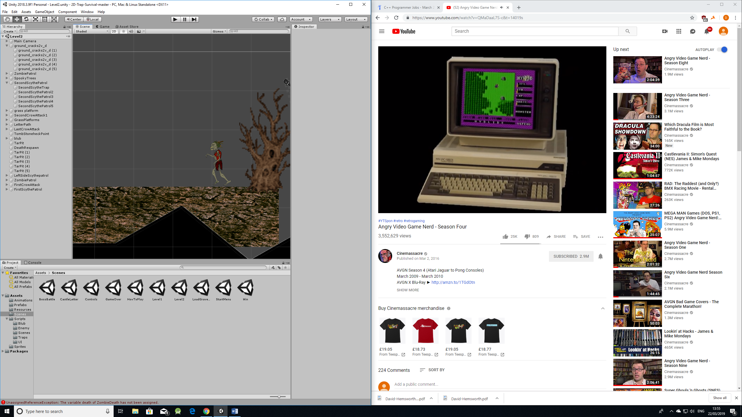

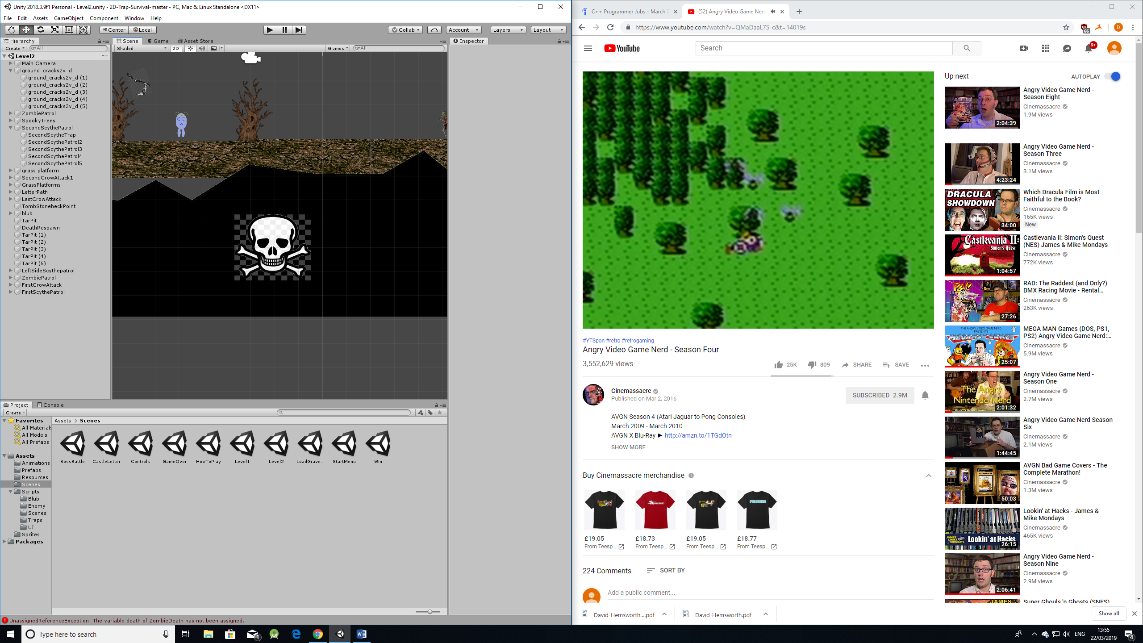

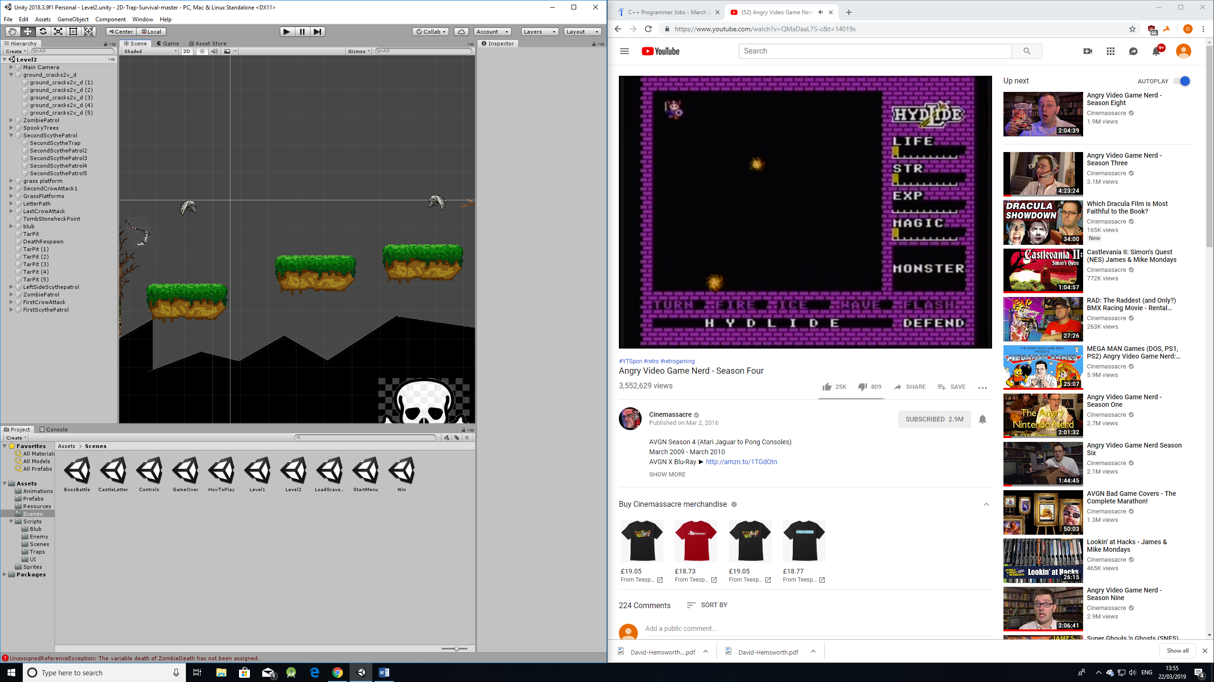

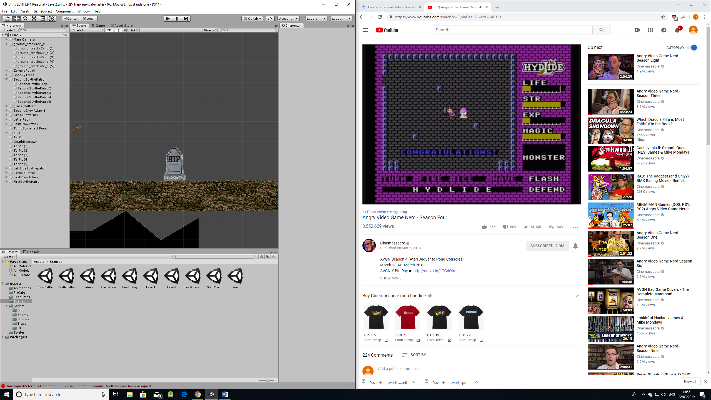

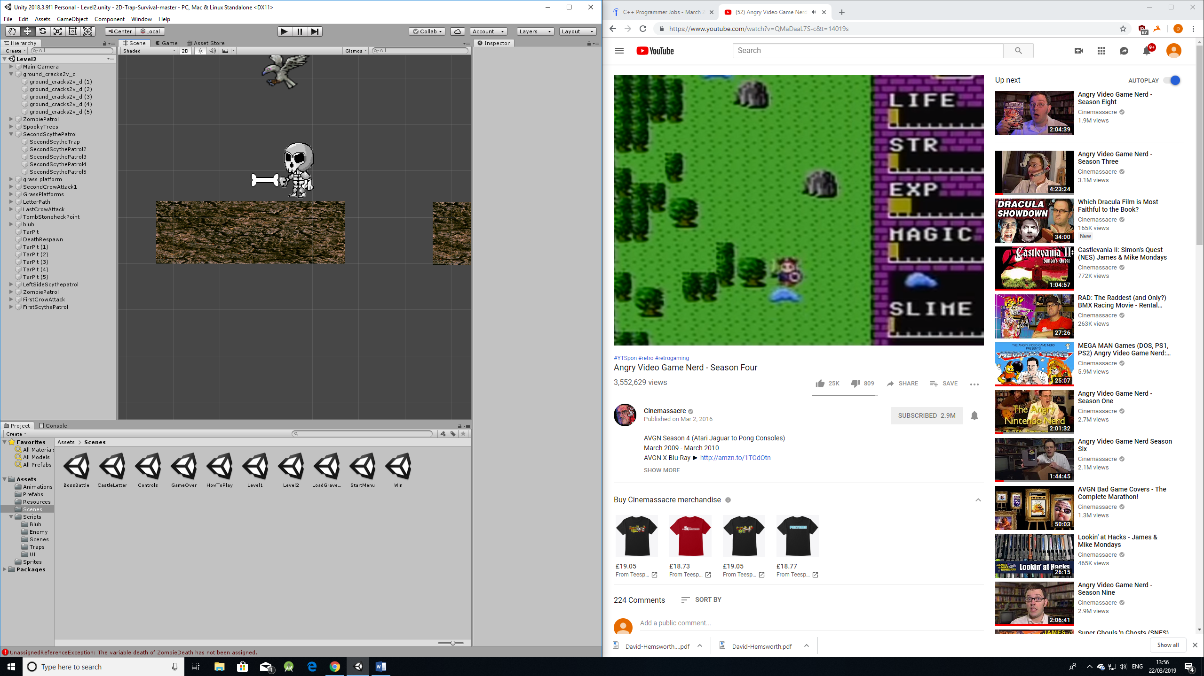

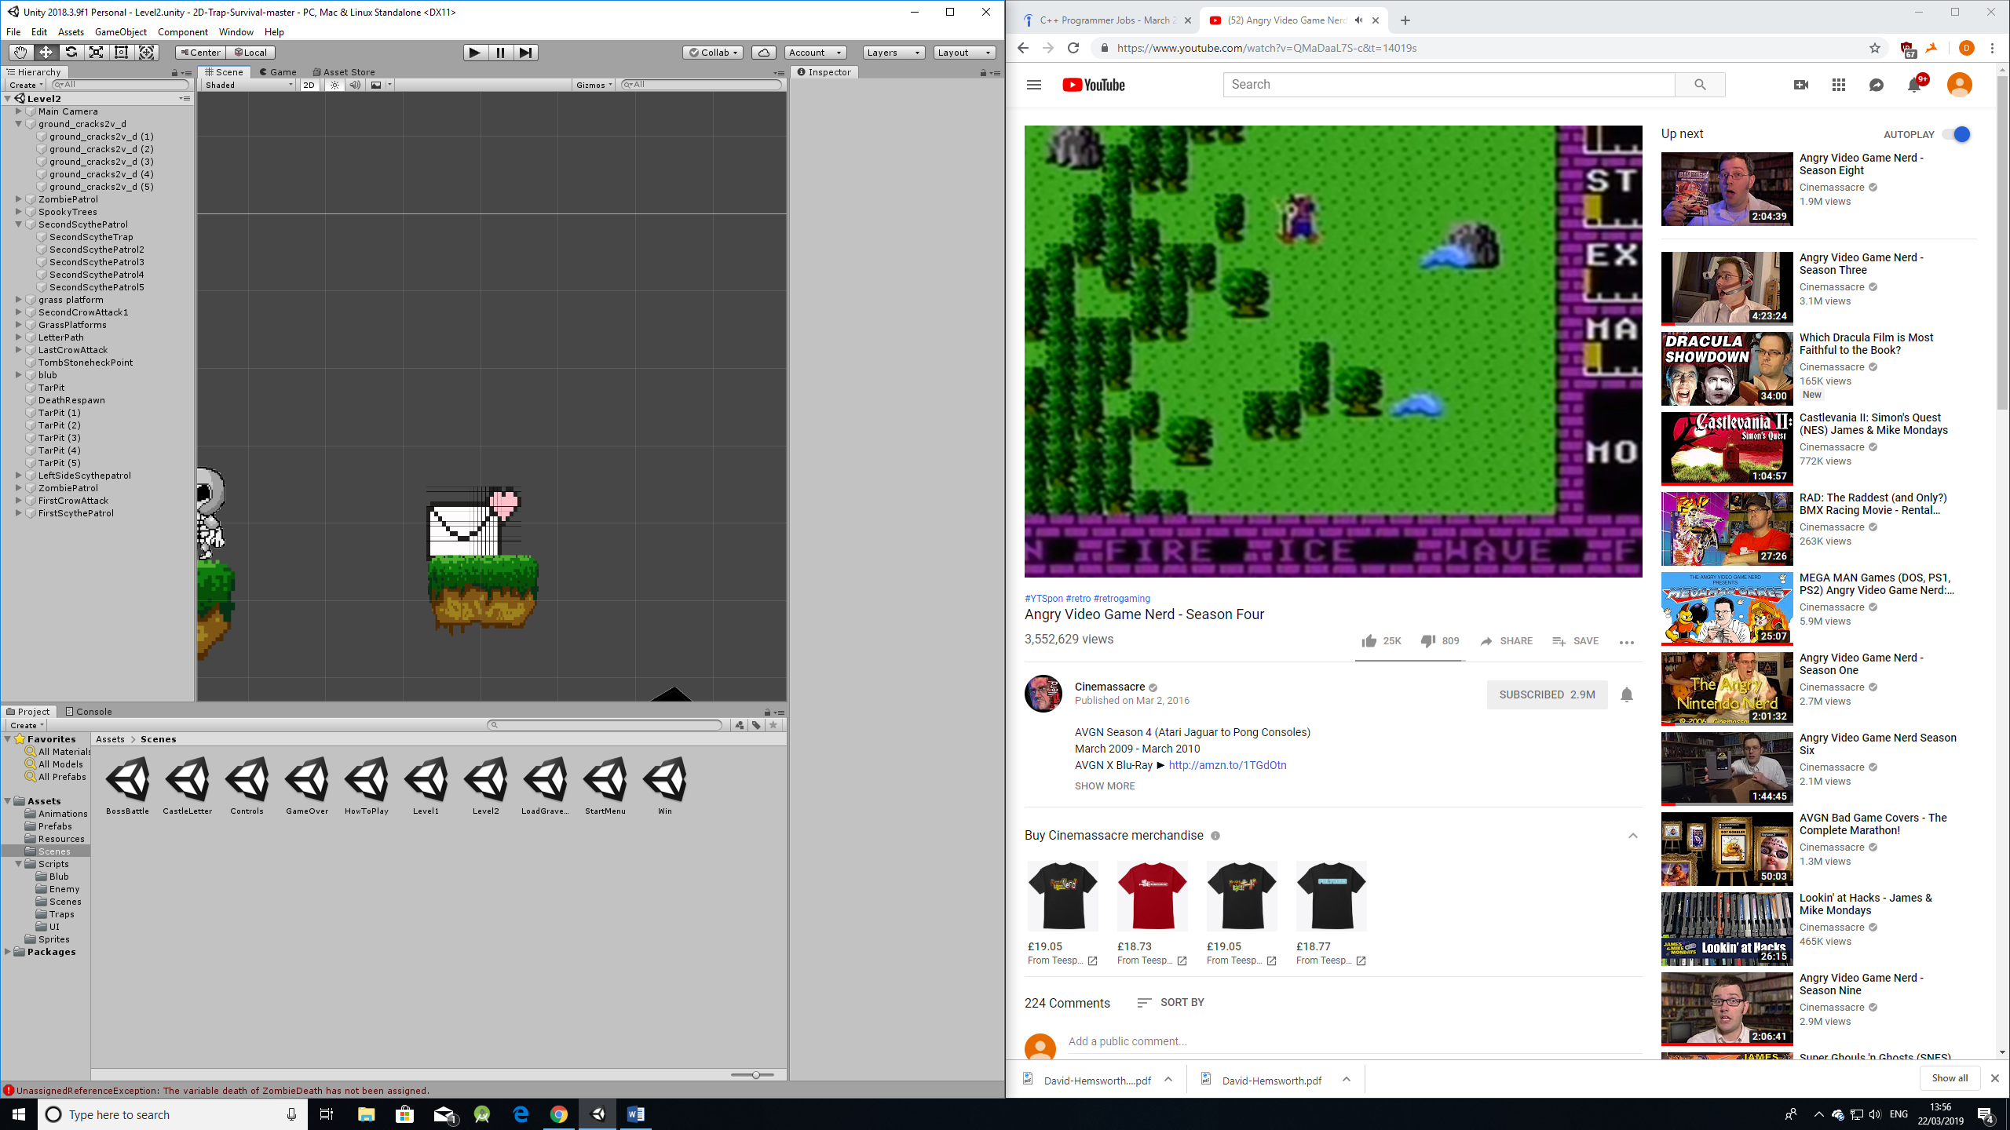

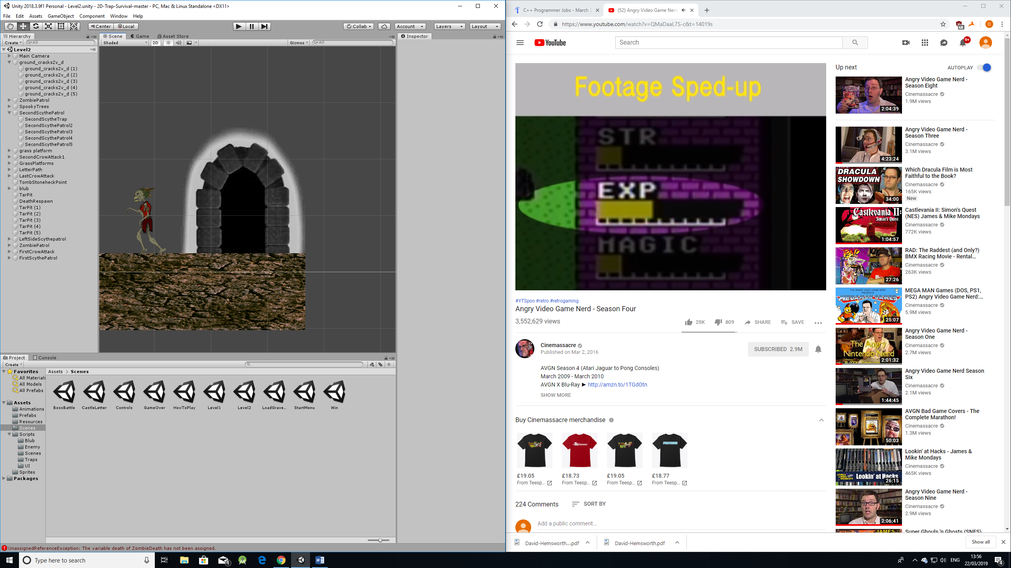

Boss Level Key